136-137: Introducing Platform Surface Interior Angle and Its Role in Flake Formation, Size and Shape

Four ways archaeologists have tried to gain insights into how flintknapping creates lithic variability are fracture mechanics, controlled experimentation, replication and attribute studies of lithic assemblages. Fracture mechanics has the advantage of drawing more closely on first principles derived from physics and material sciences, but its practical relevance to controlled experimentation, replication and lithic studies more generally has been limited. Controlled experiments have the advantage of being able to isolate, and quantify the contribution of, individual variables to knapping outcomes, and the results of these experiments have provided models of flake formation that, when applied to the archaeological record of flintknapping, have provided insights into past behavior. Here we develop a linkage between fracture mechanics and the results of previous controlled experiments to increase their combined explanatory and predictive power. We do this by documenting the influence of the Herztian cone of formation, a constant in fracture mechanics, on flake platforms. We find that the platform width is a function of the Hertzian cone constant angle and the geometry of the platform edge. This finding strengthens the foundation of one of the more influential models emerging from the controlled experiments. With additional work, this should make it possible to merge more of the experimental results into a more comprehensive model of flake formation.

# Introduction

There is considerable literature dedicated to understanding how flakes form. This understanding has been developed primarily through the field of fracture mechanics (e.g. Cotterell and Kaminga etc., Speth 1972) and controlled (e.g. Speth, Pelcin, Dibble etc.) and replicative experimentation (e.g. Eren etc.). These approaches each have their own strengths and weaknesses; however, one way to explore the differences between them is in the directionality of inference. Fracture mechanics starts with first principles, or laws drawn from physics and material sciences in particular, concerning how fractures should form in brittle solids to then, through explicit mathematical equations, make deductive predictions about how flakes should look (size and shape) under varying conditions of force application and properties of the solid. To the contrary, controlled and replicative experiments have been used as experiential approaches where observation of varying conditions of flaking and core preparation (where the core is struck, the hammer type, how the platform is prepared, the angle of strike, etc.) leads inductively to building of statistical models of flake formation without going explicitly into the first principles of solid fracture.. Both methods for understanding flake formation —applying mathematical models of first principles of fracture mechanics and building statistical models between observed experimental variables — are, of course, valid and useful, and the relationship between what is learned from doing (experiments) and what is learned from knowing how it should work in principle (fracture mechanics) should feedback on one another, with each informing the other in an iterative loop. Without this, we would be compelled to study flake formation and the underlining principles of fracture through attribute analysis of archaeological assemblages.

** Alternative Paragraph ** Cone vs Flake.

Understanding first principles causality from statistical modeling of attribute data, however, is challenging. McElreath (2018) gives the example of trying to understand the physics behind race cars by measuring their attributes. Knowing the speed and handling characteristics of each car, eventually the right things could be measured on each car to build statistical models with enough predictive power to know how a new car might perform in a race, but it would be quite difficult to infer the general physical concepts (and laws) like torque, angular momentum, friction, conservation of energy, etc. from these statistical models. Of course, with prior knowledge of the physics, finding the right attributes to measure on the cars and statistical modeling are more quickly and accurately done. This is important because even when the physical laws are known, modeling them directly can be prohibitively complex or computationally expensive (e.g. air resistance) whereas experiments and statistical models can more efficiently arrive at useable solutions.

Admittedly, the circular relation between flake formation and the role of fracture mechanics within it has been difficult to establish. Fracture mechanics itself is a longstanding and widely-applied field of study, but its practical application has been exteremely limited in our field, with the best examples coming from the papers of Cotterell and Kamminga () and of Speth (1972). These papers start with the physics of fracture mechanics in brittle solids to then explain how flakes are formed and, therefore, why they vary. Some features, like the bulb of percussion, are more easily directly accounted for in fracture mechanics (e.g., Hertzian cone formation) whereas for other attributes, like flake size and shape, the conceptual and mathematical frameworks are provided. However, as with the just mentioned example of air resistance, translating the physics of how flakes are formed into a workable model that can predict flake size and shape given the relevant parameters (e.g. core shape, angle of blow, force of blow, etc.) has not come to pass (cf. Speth 1972), and it may not come to pass any time soon. [give example of age of the known universe fracture mechanics model].

So instead, while some papers on controlled experiments in flake formation may cite papers from fracture mechanics, their approaches are all based on statistical modeling of the relations between variables of flaking and flake outcomes. Speth’s work on this topic is a good example. His 1972 paper uses fracture mechanics to derive a formula to predict flake size which is then tested against a set of actual flakes from a prehistoric site. By 1975 and again in 1981, Speth had moved to experimental approaches (ball bearings on glass) and the connection back to fracture mechanics had all but disappeared. Dibble goes further and simply dismisses fracture mechanics from the start as nearly irrelevant (Dibble and Whittaker 1981). Instead of looking to fracture mechanics for insights into what to study, experimental studies are being informed by replicative knappers and observations on how actual lithic assemblages vary. Dibble is explicit in stating that his experimental research is based on what knappers would have been able to control (Dibble and Whittaker 1981; Dibble 1997). Coming back to the race car analogy, we are carefully building cars controlling for engine size, wheel configurations, foils, etc., things that are generally thought to be important for making a car go fast, and then measuring their speeds. Although it is also difficult to go in the other direction (from statistical modeling to first principles) due to the complexity of variables involved in a simple flaking event, the controlled experiment papers have not produced a general model of how flakes form. Instead, we have a series of statistical models that are difficult to relate to one another. The strongest and most influential of these is the model of Exterior Platform Angle and Platform Depth, or the EPA-PD model.

The EPA-PD model states that flake size (weight) is primarily a function of two important variables: exterior platform angle (EPA) and platform depth (PD). Increasing either increases flake size, but the relationship between the two is geometric such that at higher values of EPA changes in PD have a greater effect on flake size. The EPA-PD model has been replicated in multiple experiments, including those in the material sciences (Dibble and Whittaker 1981; Dibble and Pelcin 1995; Speth 1975, 1981; Dibble and Rezek 2009; Lin et al. 2013; Chai and Lawn 2007a), is known to work across raw material types (Dogandzic et al. 2020), is known to work in actual lithic assemblages (Dibble 1997; Lin et al. 2013; Rezek et al. 2018), and is argued that in certain settings of core surface morphology it can override the effects of that morphology on flake size and shape (Pelcin 1997; Rezek et al. 2011). The EPA-PD model of flake formation, however, cannot be used to explain all the variability on its own. For instance, beveled flakes, where the volume behind the platform is thinned, are not easily included into the model (Leader et al. 2017). Beveled flakes are typically larger (weight) than the EPA-PD models predicts given their lower platform depths. The EPA-PD model also does not explain why flake size and shape change with varying angles of blow and platform shape (Clarkson and Hiscock 2011; Dibble and Rezek 2009; Magnani et al. 2014), and it does not account for flake width, which is obviously a major component of shape. It is also worth noting that while the percentage of variability in weight explained by the EPA-PD model(R2) is typically high in the Dibble glass experiments, it is far lower in actual lithic assemblages (Clarkson and Hiscock 2011). It is low enough that its utility for measuring retouch intensity (i.e. knowing how much mass has been removed from a flake through retouch) is limited (Hiscock and Tabrett 2010; Dogandzic et al. 2010), and so there have been various proposals to improve the statistical modeling of flake weight from different sets of platform measures (Braun et al.; Dogandzig et al.; Archer et al.). Again, though, without a general theory, it is not really clear why one measurement technique should work better than another, and success is measured by R2 values again empirical data instead of theoretical predictions (e.g. Muller and Clarkson; Archer). The problem is that our knowledge of how flake formation works is still too limited to be translated to measurable attributes.

Here we propose to build on the EPA-PD model by 1) switching the focus from variables controlled by the knapper to variables that might be more directly related to flake initiation and formation, and by 2) drawing insights from the fracture mechanics literature.In particular, we start with the proposal that Hertzian cones, the angle of which is constant in percussive fracture mechanics has a measurable impact on flake formation.

When a core is struck, the force of impact begins to produce a hertizian cone or “cone crack” at the point of percussion (Figure?). The hertzian cone is the characteristic feature of Hertzian fracture that is produced when a hard indenter is pressed onto the flat surface of a brittle solid (Roesler 1956, Frank and Lawn 1967, Lawn et al. 1974, Kocer and Collins 1998, Chen et al. 1994). It refers to the truncated cone below the impact surface (see figure). In archaeology, this is often referred to as conchoidal fracture. While the size of the Hertzian cone is dependent on variables such as the indenter’s radius, impact velocity and fracture toughness of the brittle solid, the cone angle remains unchanged (Chaudhri and Chen 1989, ). The cone angle (sometimes referred to as the included angle in fracture mechanics literature) is the apex angle of the Hertzian cone.. Though the orientation of the Hertzian cone can be altered by the change of angle of blow (Lawn et al. 1974, Chaudhri and Chen 1989, Akimune 1990, Chaudhri 2015), this apex angle remains constant according to its raw material (Fischer-Cribbs 2007). A number of fracture mechanics studies have demonstrated that the Hertzian cone angle is a constant around 136° for soda lime glass (Roesler 1956, Lawn et al. 1974, Kocer and Collins 1998). Similarly, this value is also reported in Cotterell and Kamminga (1987).

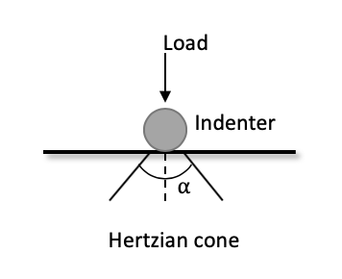

Figure. Hertzian cone

The cone crack grows as force is transferred to the core. Once the crack reaches a certain length the crack’s propagation path will no longer be Hertzian. Instead of propagating along edges of the initial Hertzian cone, the crack will continue almost parallel to the core surface to form a flake (Cotterell and Kamminga 1985, 1987). Although the hertzian cone is only associated with the initial crack formation, the angle of the cone leaves a marked impression on the morphology of the ventral surface of the flake (Figure ?). Since the angle of the cone is constant, it is possible to use the influence cone on ventral surface morphology to estimate flake morphology. Here we present a new measure called platform surface interior angle (PSIA). It is our prediction that this angle is a constant that directly follows from the constant of the Hertzian cone angle. If our prediction is correct, then it means that platform width is determined by the formation of the hertzian cone and where the core is struck. As a result, platform width (PW) is integrated into the EPA-PD model, in a way that is grounded in fracture mechanics via PSIA. This model also has behavioral implications that it may explain how the manipulation of the platform impacts flake morphology.

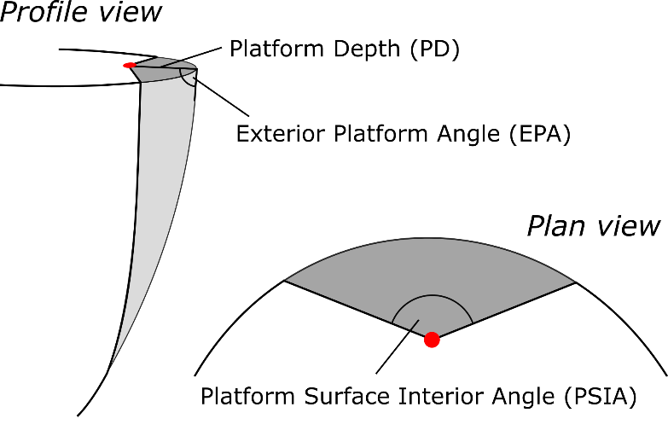

To test this model, we examine several sets of flakes, including flakes produced in the Dibble glass experiments and flakes from replication experiments, using several methods to measure the PSIA. We find that the mean angle in all datasets, regardless of how it is measured, is the same (approximately 136 degrees) and quite consistent with above mentioned values for Hertzian cone formation (Cotterell and Kaminga 1987). There is some variability in the PSIA, and it is clear that this variability cannot be solely attributed to measurement error. In the Dibble glass experiments, where key variables are controlled, there is some indication that the PSIA responds to the angle of blow. Our finding is consistent with all of the empirical results of the Dibble experiments and it explains some of the patterns in those data that previously were unaccounted for. When PSIA is combined with exterior platform angle, we may have a model for flake formation that can explain a larger portion of the variability we see in stone tool assemblage and that may allow for a closer link to predictions coming from fracture mechanics.

# Materials and Methods

We examine the platform surface interior angle in three different datasets. First, we examine glass flakes and cores coming from the Dibble controlled experiments in flake formation (Dibble and Rezek 2009; Rezek 2011; Lin et al. 2013; Magnani et al. 2014; Leader 2017). This dataset has the advantage that a number of potentially important variables are either controlled for or measureable. These include the exterior platform angle, the angle of blow, the hammer type, raw material, and metrics such as platform thickness, platform width, flake length, width and thickness, and flake weight. Hereafter this dataset is referred to as the Dibble glass data. Second, we compare the findings from the Dibble glass data by measuring the platform surface interior angle in a large dataset of 568 complete, unretouched flakes from 45 discrete reduction sequences produced through replicative experiments by knappers that were naïve towards the objectives of this study. These flakes were made by several knappers with the intent of replicating various Middle and Upper Paleolithic core reduction strategies from the initial decortification of the core through to flake production and core maintenance. These flake production sequences were generated by 3 knappers. Nodules of high-quality Bergerac and Sénonien flint were used which originated from the southwest region of France (Turq et al., 2008). These nodules varied in initial weight from ~480–4100 g. For each of the flakes coming from these reduction series, the technology and the type of hammer (hard hammer, soft hammer and indirect percussion) are known. Hereafter this dataset is referred to as the Campagne data (see Archer et al. 2020 for additional details on the structure of this dataset). Third, in addition, we measured a small set of flakes produced at the Max Planck Institute in Leipzig, Germany, in the context of teaching, replication, and experimentation. In this case, no details are known about how the flakes were produced, and this set of flakes is used here only to test a method for measuring the platform surface interior angle.. Hereafter this dataset is referred to as the MPI data.

The methods used to measure the PSIA varied substantially between the three datasets. First, for the Dibble glass data, we used the following procedure. Dibble and colleagues used several core forms, but the first and most common type is what was called the semispherical core. This core (reproduced here) looks like a loaf of bread with flat, squared off sides and back, and a curved or domed flaking surface. An unworked example of this core type was scanned using an XX surface scanner. The resulting mesh was then processed in R to rotate the platform to be perpendicular to the Z axis (or coincident with the XY plane). The XY coordinates of the triangles forming the platform were then extracted from this model and a convex hull fit to this cloud of points to have the full outline of the platform on the Dibble semispherical cores (Figure 1). Next, we extracted just the portion of the outline that is where flakes are struck from these cores, and we fit a polynomial curve to these points. Using the formula for this curve, we created a series of equally spaced (in X) points along the platform edge (see (see Figure 1). We then filtered Dibble’s glass data to have only flakes made from the semispherical cores by hard hammer. We include only flakes with a feather termination, and we exclude flakes coming from experiments on platform beveling (Leader et al. 2017) and so-called ‘on-edge’ core strikes (Magnani et al. 2014). Knowing that Dibble and colleagues tried to strike flakes from these cores at the center or peak of the core surface curvature, we use the platform depth reported for these flakes to position the point of percussion relative to the set of platform edge outline points described above. Next, working back from the platform edge, the locations left and right of the point of percussion and on the platform edge points that yields a platform width equal to the reported platform width for that flake is determined. Finally, the PSIA is calculated (arc-cosine of the dot product of two normalize vectors) as the angle between the two line segments formed by the left platform width point and the point of percussion and the right platform point and the point of percussion.

[I will insert a new figure showing a Dibble glass core and how the measures we talk about here are made]

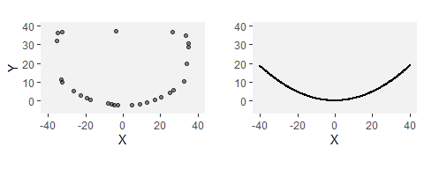

*Outline of Dibble core surface (left) and the polynominal fitted to the core edge (right).*

We note that there are several potential sources of error in this method. First, we are assuming that each flake is struck from the center of the core, and while this was the intention in the Dibble experiments, there is certainly some error associated with this. Second, we are assuming that the flake removal is centered on the center of the core and parallel to the lateral sides of the core (i.e. that it is not twisted to one side or the other). To the extent that either of these assumptions is invalid, it will impact the angle calculation. [could simulate this to get an idea of the error]

To verify the angles computed in this way from the Dibble glass data, we also measure this angle directly with digital calipers and a goniometer on a subset of these flakes. We use two methods of measuring to begin to test how best to measure the PSIA by hand. In the first method, we measure the three sides of the triangle formed by the two platform width points and the point of percussion using digital calipers precise to .01 mm [check this]. Using standard trigonometric formulas, we then calculate the interior angle of this triangle that corresponds to the platform surface interior angle as described above. In the second method, we use a digital goniometer precise to XX degrees [check this] to record this angle. The joint of the goniometer is positioned at the point of percussion and the jaws positioned to cross the two platform width points. Both of these methods come with possibilities for error. Both are impacted by one’s ability to pinpoint the point of percussion. In the Dibble glass flakes, because the core edge is standardized, identifying the two platform width points is fairly straightforward. However, in the goniometer method, taking the measurement to these points while avoiding the curvature of the bulb of percussion is not without some difficulties.

For the Campagne data, we use the following procedure. All of the flakes were scanned using an Artec surface scanner. Each of the flake meshes was then landmarked (see Archer et al. 2020 for additional details on the scanning and landmarking). For our purposes, three of these landmarks are important: the two points (left and right) where the interior platform intersects the core surface (i.e., the two ends of the platform width) and the point of percussion. These three points are analogous with the three points described above for computing the platform surface interior angle. This angle, therefore, can be once again computed as the dot product of these two line segments. However, there is an important difference in that with the Dibble glass data all computations are with two dimensional line segments and in the Campagne dataset the line segments are in three dimensions. In the latter case, the angle is computed in a two dimensional plane that is coincident with both line segments, but we note this difference because it could introduce a certain amount of incomparability in the two datasets. Our expectation is that these angles could average larger than the Dibble glass data because, for instance, lifting the point of percussion relative to the two platform points would result in a larger PSIA.

Lastly, for the MPI data, we use only the goniometer method described above. One of us (MW) made the measurements with instructions only on how to perform it.. To avoid bias, MW was given no prior knowledge of the results of the previous studies outlined above or of how PSIA may function in flake production. In the course of measuring the flakes, several problematic platforms were identified where the measurement of the PSIA was not as clear as the person selecting the flakes (SPM) had initially believed. These flakes were removed from the analysis.

We use the R () statistical environment to do this analysis. This paper is an rMarkdown document, and it is included in the supplementary information along with the data files needed to compile the document and replicate all of the figures, tables, and statistics.

# Results

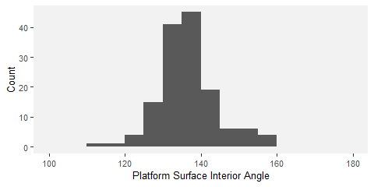

*Distribution of estimated platform surface interior angles (PSIA) based on the Dibble glass flakes.*

Figure 2 shows the distribution of platform surface interior angles in the Dibble glass dataset. The distribution has a mean of 136.49±7.56. Variation in this angle does not seem to be related to platform depth, exterior platform angle or weight (Figure 3). There is a relationship between platform width and the platform surface interior angle such that larger angles result in wider platforms, which is to be expected (see Figure 3).

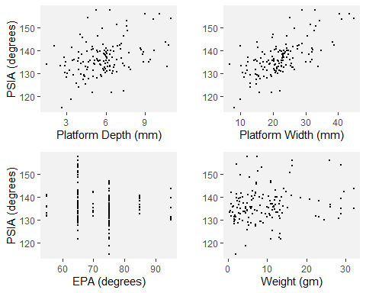

*PW, PD, EPA and weight against the estimated platform surface interior angles based on the Dibble glass flakes.*

There also appears to be a relationship between the angle of blow and the PSIA (Figure 4). While there are fewer cases with angles of blow less than 20, there is some indication in the data that lower angles of blow may be correlated with lower PSIA. However, once the angle of blow is between 10-20 degrees or higher, the angle of blow is not correlated with the PSIA.

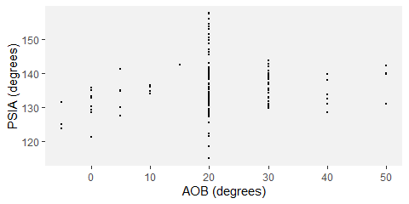

*AOB against the estimated platform surface interior angles based on the Dibble glass flakes.*

Another way of looking at the relationship between platform width and PSIA is to calculate what the platform width would be if the PSIA is a constant and compare this to the actual platform width. We can do this by placing the point of percussion on the same platform outlines as above using the known platform depth for each of the flakes in the Dibble glass data set. We then use the average PSIA computed above to extend two vectors from this point of percussion to the platform edge. Where these vectors intersect the platform edge defines the left and right limits of the platform width. This estimated value is then plotted against the actual, measured platform widths (Figure 5).

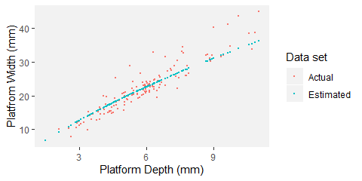

*The actual platform depth to platform width data from the Dibble glass core flakes and the estimated platform width using the average platform surface interior angle calculated previously.*

Figures 6 and 7 show comparisons of the results of the calculated PSIA presented above with direct measurements of this angle on a sample of 49 of the Dibble glass flakes. For this sample, the PSIA is 135.71±4.86. When measured with a digital goniometer the angle is 133.44±4.61; when measured with digital calipers and calculated using trigonometry, the angle is 135.86±8.85.

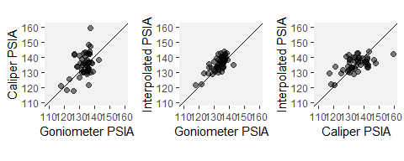

*A comparison of the interpolated platform surface interior angle, this same angle as calculated from caliper measurements, and this same angle measured with a goniometer. All measures are in degrees.*

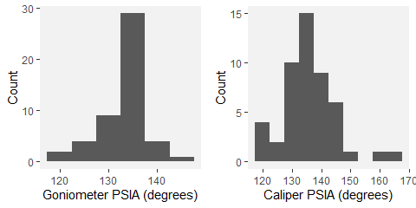

*The distributions of platform surface interior angle as directly measured with a goniometer and as calculated from caliper measurements.*

The distribution of the PSIA for the 568 flakes in the Campagne dataset is shown in Figure 8 with color coding for the type of percussion technique. Here the mean platform surface interior angle for all flakes is 138.63±13.27. Punch flakes have a lower platform surface interior angle (stats), and soft hammer flakes have a mean of XX. When we look at only the hard hammer flakes, which is the technique used in the Dibble glass dataset, the mean platform surface interior angle is 140.36±12.38.

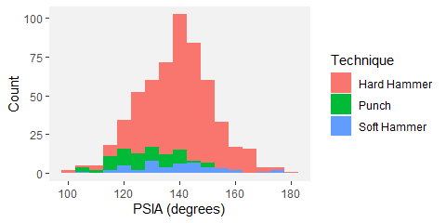

*Distribution of platform surface interior angles in the Campaigne data set color coded by percussion type.*

In the Campagne data, PSIA does not covary with platform width, platform depth or the shape of the platform (as measured by the ratio of platform width to platform depth). Though sample size is potenaitally a problem, there is perhaps an indication that for larger platform depths, there is less variability in the platform surface interior angle.

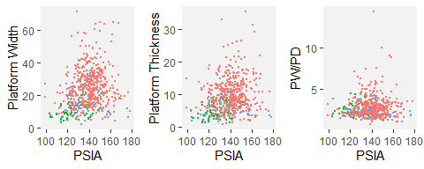

*Platform surface interior angle as a function of platform width, platform depth, and EPA in the experimental flake collection. Color coding is the same as in Figure 8.*

The distribution of PSIA in the MPI dataset as measured by a digital goniometer is presented in Figure 10. This dataset contains 67 flakes, and the mean is 137.75±10.97, in keeping with the other datasets.

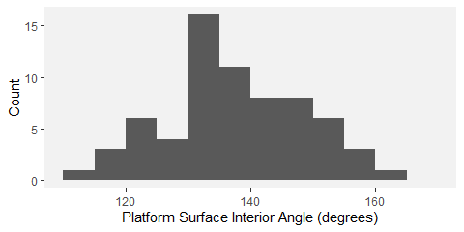

*Distribution of platform surface interior angle in the MPI flakes dataset as measured by a digital goniometer.*

# Discussion

Each of the datasets and measurement methods used to determine the PSIA yielded very similar results, and these results are consistent with the prediction based on the already known and constant angle of Hertzian cones (136-137 degrees). While these results directly incorporate the formation of platform width into the EPA-PD model of flake formation, they also suggest that the existing model requires additional nuance. All other things being equal, the relationship between PSIA and platform width indicates that what determines the size of the flake, is how far into the core it is struck. Specifically, because of the constant PSIA, the deeper into the core the flake is struck, the greater the platform(?) width will become(and the thicker the flake becomes as well). However —and this is the nuance — while platform depth is normally a good proxy for how far into the core the flake is struck, it is not exactly the same thing. What platform depth really measures is how far into *the existing platform of the core* the flake is struck. Beveledflakes illustrate this point.

Beveled flakes are ones where material is removed behind the platform prior to striking the core. Dibble and colleagues recognized that beveling altered the EPA-PD model of flake formation such that the interaction of platform depth and exterior platform angle no longer predicted flake size (Leader et al.). Namely, beveled flakes have too thin a platform for their size. The reason for this could be that the beveling in that dataset, while trimming the platform (and, thus, decreasing the platform depth), the volume of the material trimmed off the core (and the resulting flake) was not big enough for the flake weight to be proportionately smaller and corresponding to its smaller (trimmed) platform depth. Nor the bevels are long enough along the exterior surface of the cores to decrease the flake length. In any case, if we modify the EPA-PD model by replacing PD with how far into the core the flake is struck, which can be reconstructed by using PSIA, the bevel flakes no longer represent anomalies. To illustrate this point, we examine some of the beveled flakes in the Dibble glass dataset.

In the Dibble glass dataset there are 11 beveled flakes coming from semispherical cores and otherwise conforming to our selection criteria. They are plotted in Figure 11 along with the non-beveled flakes. It is clear that the presence of platform beveling changes the relationship between platform depth and platform width – for a given platform width, the beveled flakes have much shallower platforms (smaller PD) than expected. As said above, for a given platform depth, they also have much bigger weight than expected. In the original form of the EPA-PD model, this difference is hard to reconcile (Leader et al. 2017). To illustrate the power of PSIA to explain this difference, we build a linear model to estimate platform depth from the PSIA and platform width on the non-beveled flakes in the Dibble glass dataset. We then use this model, and the average PSIA as reported above for the non-beveled flakes, to reconstruct the “theoretical platform depth” of the beveled flakes. By theoretical platform depth, we mean the platform depth as it would be present on those flakes if they were not beveled (in non-beveled flakes, theoretical platform depth is the same as platform depth). When this is done, the theoretical platform depth” for the beveled flakes plot on the same trend line as (the platform depth) for the non-beveled flakes (see Figure 11).

This reconstructed theoretical platform depth can then be used to improve the EPA-PD model to give better estimates of flake size. The main aspect of size that Dibble and colleagues have focused on for the beveled flakes is weight (Leader et al. 2017), and so we model flake weight as a function of EPA, platform depth and the interaction of the two (see Figure 11). The cube root of weight is used to correct for the difference between the scales of variance of the different dimensions in the model. Next, we use this same model to predict flake weight in the beveled flakes using the platform depth as measured on these beveled flakes. In this case, the modeled flake weights are much too low (see Figure 11). Finally, we use the theoretical platform depths of these flakes, as reconstructed above, to predict their weight. In this case, the flake weights plot in among the rest of the non-beveled flakes (see Figure 11). Thus the beveled flakes are of the correct size according to the EPA-PD model when we think of PD in this model not as a measure of the observable platform depth but rather as a measure of the theoretical platform depth. This then determines the flake width via the PSIA and the platform width.. From this perspective, beveling is primarily a feature of platform morphology, whose variability alters the relationship between platform depth and platform width (Figure xx). Beveling, at least to the intensity of trimming as done in Dibble glass cores, can then be used to manipulate this relationship, that is, to change the morphology of the platform (flatten it and make it wider) while keeping the size of the flake more-or-less the same.

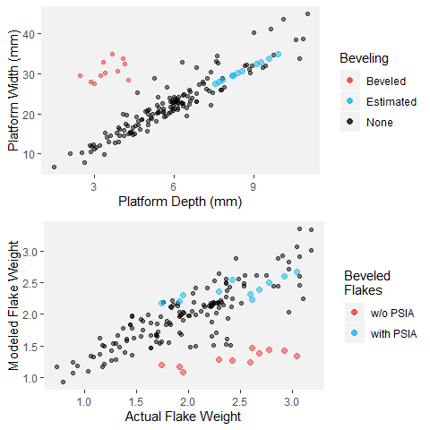

*Platform depth to platform width including beveled flakes (left). Estimated points are the beveled flakes with reconstructed theoretical platform depths based on the average PSIA and their actual platform width. To the right, the actual flake weight is compared to the predicted flake weight based on an EPA-PD model for non-beveled flakes. The predicted weight using the actual (w/o PSIA) and the reconstructed (with PSIA) platform depths for the beveled flakes are then plotted as well.*

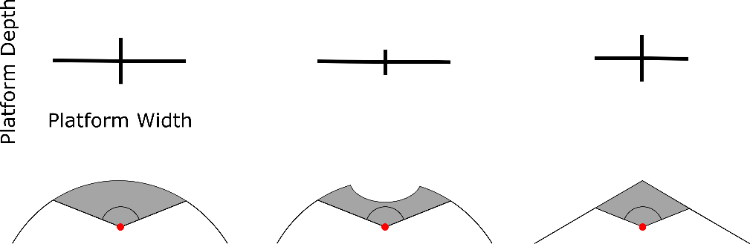

There is some indication in the Dibble glass data that the angle of blow may impact the PSIA. At low angles of blow (0 being at the right angle between the indenter and core platform, see Figure 2 in Magnani et al. 2014: 38), the PSIA is below average, and it appears to increase until the angle of blow reaches between 10 and 20 degrees (from perpendicular, that is, 100 and 110 degrees between the indenter and core platform), after which the PSIA remains essentially unchanged (refer to previous figure). With the caveat that the Dibble glass data set has very few cases with angles of less than 20 degrees, the fracture mechanics literature suggests a relationship like this. The angle of blow changes the direction, though not the size, of the Hertzian cone such that flakes struck from cores with a high angle of blow (oblique strike) should have “steeper and less prominent cones and less salient bulbs of percussion than flakes which are struck more steeply [or more perpendicular]” (Speth 1972:38). Experimentally, however, Magnani et al. (2014) seem to find the opposite. They report that a negative angle of blow (here values less than 0 meaning a strike directed into the interior of the core, with the sharp angle between the indenter and core platform) have smaller bulbs relative to the weight of the flake. In our Campagne data set, we see a difference between flakes made from direct hard-hammer percussion and those made with a punch technique. The latter cluster at the low range of PSIA. This difference could be interpreted as reflecting a difference in the angle of blow in that punch flakes are more likely to be struck perpendicularly to the platform surface. More work needs to be done, in particular in analyzing the Dibble glass data set where angle of blow is well controlled, but we suggest that increasing the angle of blow has the effect of tipping the direction of the Hertzian cone such that it intersects the core surface not as a circle but rather as an ellipse (see Figure). This is a phenomenon that has been repeatedly documented in fracture mechanics (Lawn et al. 1984, Chaudhri and Chen 1989, Chaudhri 2015 ). Although the angle of the cone itself remains unchanged, its intersection with the surface broadens and results in higher platform surface interior angles. Thus, if this suggestion is correct, striking a core with a high angle of blow will result in a larger platform width for a given platform thickness. Potentially, this can explain also the smaller platforms in indirect percussion in general as them being the product of a vertical strike (angle of blow around 0) rather than of the percussion technique itself.

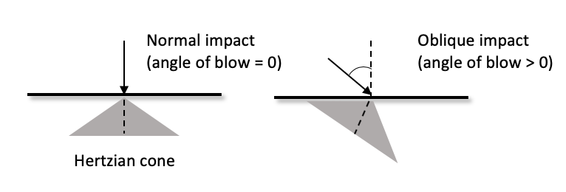

Figure. How angle of blow tilts the hertzian cone - from Chaudhri et al. (1989)

The direct measurement of PSIA in a subsample of the Dibble glass flakes shows that our method for finding this angle using the core morphology and platform depth is working. However, there is variability in this angle depending on how it is measured. In general it seems that the direct measurement with a goniometer performs better than the indirect calculation of the angle from three caliper measurements. Of the two methods, the caliper measurements show greater variability than do the goniometer measurements (it has to be stressed also that the sample size of people measuring is not bigger than 2). The caliper method can also fail completely when measurement error produces a triangle with impossible side lengths (e.g. the sum of the two shorter sides does not equal the length of the longest side). Importantly too, this is only knowable once the measures are taken and an angle is calculated, making it much more difficult to correct, whereas the goniometer method produces an angle each time. Our study, however, does not indicate which of the three methods in this case is correct, nor do we know the error associated with any of these individual methods. Now that PSIA seems to produce results relevant to understanding flake formation, additional studies are required to better know the error distribution on an individual measure. We note too that this error distribution will likely vary with the angle itself, the size of the point of percussion, and other factors that remain to be identified. The question, however, is whether this measurement error will overwhelm patterns, such as, for instance, the one showing a potential correlation in angle of blow and platform surface interior angle. It is our expectation that with a digital goniometer, direct measurement of the platform surface interior angle can become one of the standard measurements within lithic attribute analysis, but this remains to be determined. It should also be noted that sometimes the cone crack may kink at a light angle to continue expanding. This kink may also contribute to the variability observed in PSIA (Marimuthu et al. 2016, Hu et al. 1996)

We note that our finding that the platform surface interior angle varies around a constant derived from fracture mechanics appears to be consistent with all of the findings to date of the Dibble glass experiments (). Additionally, it perhaps helps explain or account for one of the more counter intuitive findings of the glass experiments, namely that flake size (weight) is not impacted by the force with which the core is struck (Dibble and Rezek 2009). In the EPA-PD model, the amount of force required to remove a flake given a particular combination of EPA-PD is a constant. Similar findings regarding the relationship between load and platform depth was reported in the material sciences (Chai and Lawn 2007b). Subtracting force means that the flake is not initiated. Adding force does not change the size of the resulting flake. This makes sense in the PSIA addition to the model. In fracture mechanics, it is known that striking a material harder does not change the angle of the Hertzian cone. It will change the size of the cone but not the angle (Kocer and Collins 1988). Although, a more recent study by Chaudhri (2015) shows that the indenter velocity does have an impact on the hertzian cone angle: increasing impact velocity of the indenter will eventually cause the Hertzian cone angle to decrease (see also Wang et al. 2017). Thus when a core is struck, how far into the core the Hertzian cone can travel will be dependent on the hammer size and striking force, but where it is pre-determined (by core and platform variables) to intersect the core surface does not change. So striking a Dibble glass core harder at a particular point does not change the platform width, and as a result, the subsequent fracture plane that removes the flake has much less freedom to change the size of the flake.

# Conclusions

Fracture mechanics is a massive field of study with both great potential and great difficulties for understanding flake formation. The potential is that the physical laws and models coming from fracture mechanics are, ultimately, how the actions of knappers are translated to usable flakes. The difficulties are both inherent to the field itself and the complexity of the problem (some solutions require more time and computing power than exists) and relate to the challenges of interdisciplinary work where the equations and goals of one field are terribly difficult to bring into another. This later point is clearly seen in the early fracture mechanics literature and the minimal impact it has had on experimental and replicative studies of flake formation.

This said, our goal here was to return to this literature and to try to find some useful insights that could be translated to a better understanding of the underlying mechanisms (or first principles) of flake formation and that might thereby lead to a better integration of the various statistical models currently in use. To do this, we discarded the existing focus in the experimental literature on what knappers do and instead focused on attributes that may be more directly related to fracture mechanics. Thus we focused our attention on the Hertzian percussion cone as a constant and wondered if it could help explain platform width, an aspect of flake size and shape that up to now has been absent from the dominant EPA-PD model of flake formation. We measured three different collections in multiple different ways and found that in each case the angle formed by the platform width and the point of percussion to be, on average, essentially the same as what is predicted from fracture mechanics for the angle of the Hertzian cone.

We conclude that the platform surface interior angle, or PSIA, is an important determinant in flake size and shape. While it would seem that it is a constant and not under direct control by the knapper, the knapper is (unknowingly) exploiting the properties of this angle when preparing the platform and its contact with the platform surface and when deciding how far into the core to strike. In our model, this is how the PD side of the EPA-PD model of flake formation is translated into a flake of a particular size and shape. In other words, it is not the PD that directly structures flake size but rather PD is proxy for how far into the core a flake is struck which then, through the PSIA, structures the size and shape of the flake.

This, however, requires further testing, particularly with beveled flakes where PD performs poorly as a proxy for how far into the core a flake is struck. If the platform surface interior angle performs better in these circumstances, then we will have improved the EPA-PD model and helped to integrate what are now disparate studies (Dibble and Rezek 2009 and Leader et al.). At the same time, it has to be made clear that the EPA-PD model of flake formation so far has been utilized for two related but different inquiries. One is to infer control and manipulation of the knapper of the given materials during flaking, while the other is for estimating flake size. Since for the latter it is more important to know how far overall into the core the flake was struck and took its mass with it, perhaps the more accurate proxy for this would also be flake thickness rather than PD. This is especially the case where reconstructing PSIA would not be possible, like, for example, in punctiform, cortical, reworked, or damaged flake platforms.

Additionally, while our study shows that the average platform surface interior angle conforms well to predictions from fracture mechanics, it is still clear that there is variability around this mean. Given that there is certainly some chaos in flake formation, we are not sure how much variability to expect. [something about the glass cores versus the flint flakes] However, it is also clear that the model does not work at all for some flakes. We would like to propose that these flakes are not formed by percussion flaking (need to revisit the Cotterell papers and bending flakes, versus percussive flake vs. one other category) and that alternative models will be required in these cases. Clearly more data are required to begin to understand which kinds of flakes fail the platform surface interior angle model, but more importantly, more experimentation is needed to improve the current models of flake formation and their size estimation.

# Acknowledgements

The knappers in Campagne. We thank the Max Planck Society for funding portions of this work. SPM, MW, WA, ZR and TD thank Jean-Jacques Hublin for his support this research agenda. Sadly Harold Dibble died before the main findings of this paper were discovered. However, without his vision and his efforts to build a data set of flakes made under controlled conditions, this paper would not have been possible. We dedicate this paper to him.

# References